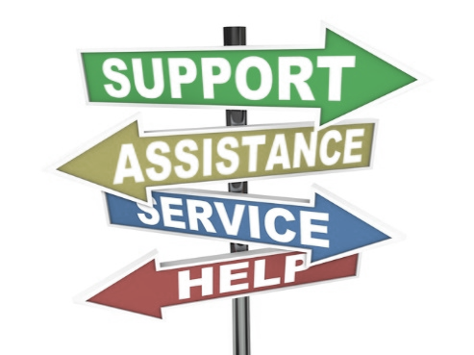 | How else can we help you?

Did you know we can provide access to support for almost any need you have? We can do this through both our services and through referrals to our partner programs.

Instructions
- Mark any and all of your current needs below.
- Fill out the yellow highlighted areas on the reverse side of this form.
- Return the form to the person who provided it to you or submit to the 2nd floor reception desk.

Job Search Needs
Resume Advice & Preparation
Interview Advice & Preparation
Job Search Advice & Preparation

Basic Needs
Basic Computer Skills
Food Pantry
SNAP benefits (food stamps)
Shelter/Rental Assistance
Health Care
Mental Health Services
Phone
Heat/Energy Assistance

Training
Vocational Training to gain a specific skill
Adult Basic Education (GED/ESL)
Citizenship Preparation
Literacy/Numeracy Tutoring
Job-focused training for young adults ages 16 to 26

Career Assistance for Specific Groups*
Veterans
Job Seekers age 55+
My job was outsourced to another country.
I am interested in mentoring youth through coaching.
Individuals in need of Legal Assistance
Individuals with Disabilities
CHA Residents
*Note: Individuals in these groups are invited to apply for programs designed specifically for them, but are also welcome and encouraged to apply for other programs.

Program Use Only

Which Pilsen Partner Program provided this form to the customer?

Chicago Citywide Literacy Coalition

Is this customer currently enrolled in your program?

Rev 1-4-18 Pilsen American Job Center

Chicago Workforce Center at Pilsen Partner Referral Form

Participant Name _______________________________ Address___________________________________

Cell Phone # _______________________ Email __________________________________________________

Referral agency:
Organization: Chicago Citywide Literacy Coalition Contact name: Robert Guzman

Email: robert@chicagocitywideliteracy.org Office # 312-659-1520 Date ____________________
Referral to: National Able Network 1700 West 18th Street Chicago IL 60608
□ Adult Education

□ Adult Literacy □ CTE-Perkins □ Illinois Department of Employment Services (IDES)

□ Vocational Rehabilitation □ WIOA Program Services/ National Able Network

□ Other (please specify) ____________________________________________________________________

Contact Name: Maria Castillo Email mcastillo@nationalable.org Office# 312-994-8300

Reason for referral: Client is interested in attending WIOA orientation program and confirmed via telephone she will attend orientation on________. Career Navigator provided WIOA flyer and explained eligibility and required documentation.

If applicable:
TABE score(s) _________________(R) _______________(M) / TABE grade level(s) _________(R) _________(M)
Date of test: ____________________________________ TABE Locator/test scores attached: □ Yes □ No
Date of retest: ___________________________________TABE Locator/retest scores attached: □ Yes □ No

Participant Outcome
______________________________________________________________________________________________________________________________________________________________________________________________________________

Instructions for participant
Bring a copy of this referral form and any other relevant documents to your appointment.
Appointment Date:___________ Time: ______________

I hereby consent to the exchange and/or release of my confidential information between the Chicago Workforce Center’s partner agencies.

__________________________________________________________________ / _____________________
Signature of participant Date

Internal Office Use Only
*Fax / Scan / Email document to the agency receiving this referral*
Chicago Workforce Center partner referrals should be emailed to pilsenreferrals@nationalable.org
or faxed to 312-994-8352.

