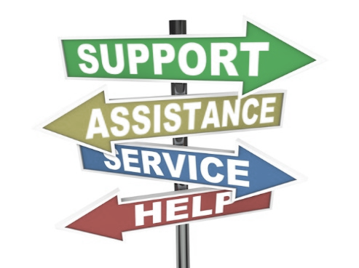 | Attention Job Seekers & Partner Programs

Assistance for job seekers is available at no cost to participants through National Able Network and our partner programs. See below to connect with our services.

Instructions
- Checkmark any and all current needs.
- Complete the chart below and follow the submission instructions.

Job Search
󠄀 Resume Advice
󠄀 Interview Advice
󠄀 Job Search Advice

Training
󠄀 Vocational Training to gain a specific skill
󠄀 Adult Basic Education (GED/ESL)
󠄀 Citizenship Preparation
󠄀 Literacy/Numeracy Tutoring
󠄀 Job-focused training for young adults ages 16 to 26

Career Assistance for Specific Groups*
󠄀 Veterans
󠄀 Job Seekers age 55+
󠄀 My job was outsourced to another country.
󠄀 I am interested in mentoring youth through coaching.
󠄀 Individuals in need of Legal Assistance
󠄀 Individuals with Disabilities
󠄀 CHA Residents
*Note: Individuals in these groups are invited to apply for programs designed specifically for them, but are also welcome and encouraged to apply for other programs, too.

Basic Needs
󠄀 Basic Computer Skills
󠄀 Food Pantry
󠄀 TANF or SNAP benefits (food stamps)
󠄀 Shelter/Rental Assistance
󠄀 Health Care
󠄀 Mental Health Services
󠄀 Phone
󠄀 Heat/Energy Assistance

Today’s Date: ___________
Customer Information:  Who gave you this form? _____________________  Customer Name: ___________________________  Customer Phone: ___________________________  Customer Email:  ________________________________ |  | For referrals through a partner program:  Referring Partner: ___________________________  Contact Name: _____________________________  Contact Phone: _____________________________  Contact Email:  ________________________________
Submission Instructions | Via email (preferred method): pilsenreferrals@nationalable.org  In person: 1700 W. 18th St, Chicago IL 60608 (2nd floor reception)  Via fax: 312-994-8352 Questions? Call 312-994-8390.
Rev Feb 2019 Near West American Job Center (Pilsen)

