Illinois ICAPS/IET Self-Assessment Tool

The Integrated Career & Academic Preparation System (ICAPS), is the implementation of the Accelerating Opportunity (AO) initiative in Illinois. ICAPS aims to provide an integrated pathway in Career and Technical Education (CTE) for college credit and program certificate opportunities for Adult Education and Literacy (AEL) students that lack basic skills. Through ICAPS programs students work to complete their high school equivalency and are co-enrolled in credit CTE courses/certificates through an integrated instructional model—supplemented by support courses, comprehensive student supportive services, and augmented by team teaching that includes CTE faculty and basic skills instructors. The model provides career pathway/employment opportunities for students while enabling their transition into additional post-secondary certificate/degree programs.

ICAPS/IET Model One: _____ ICAPS/IET Model Two: _________________
(select one)

Program of Study (add CIP Code for Model 1): ________________________

Date of Review: ___________

Potential Credentials Earned: ________________________________________________________________

Partnership Team:
Adult Education Lead: _______________________________________________________________
CTE Lead: ________________________________________________________________________

LWIA Lead: _______________________________________________________________________

Team teachers:
- ___________________________________________

- ___________________________________________

Career Navigator for this ICAPS/IET Program:

________________________________________________________________________________
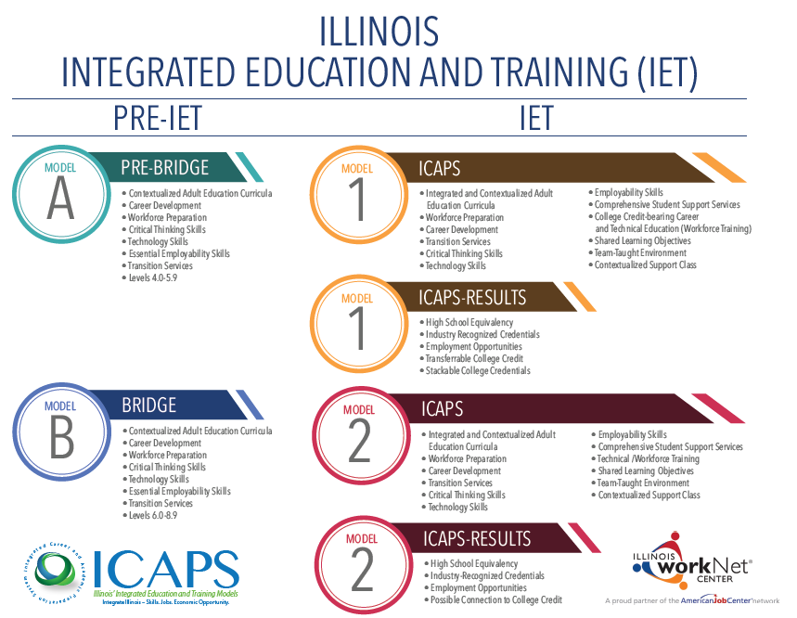
A required component of the ICAPS program, team teaching is a method by which two teachers, one basic skills/Adult Education instructor, and one college-level Career and Technical Education instructor, work together to integrate the education that is provided to students. A minimum 50% overlap of instruction is required, with an allowance of up to 25% in planning and a minimum 25% in the classroom. While the natural and encouraged progression is for a team of teachers to work from Stage One toward Stage Three, it is understood that variables such as faculty turnover, it will be necessary to be able to move fluidly between the different stages. The graphic demonstrates how a team can easily move between the three stages in the continuum. The continuum of team-teaching works by demonstrating where a team of teachers can be operating at a given point, depending on several factors including but not limited to: progress in the process of development and implementation; level of experience of one or both instructors; level of comfort, trust, and integration between instructors; level of familiarity with course content.

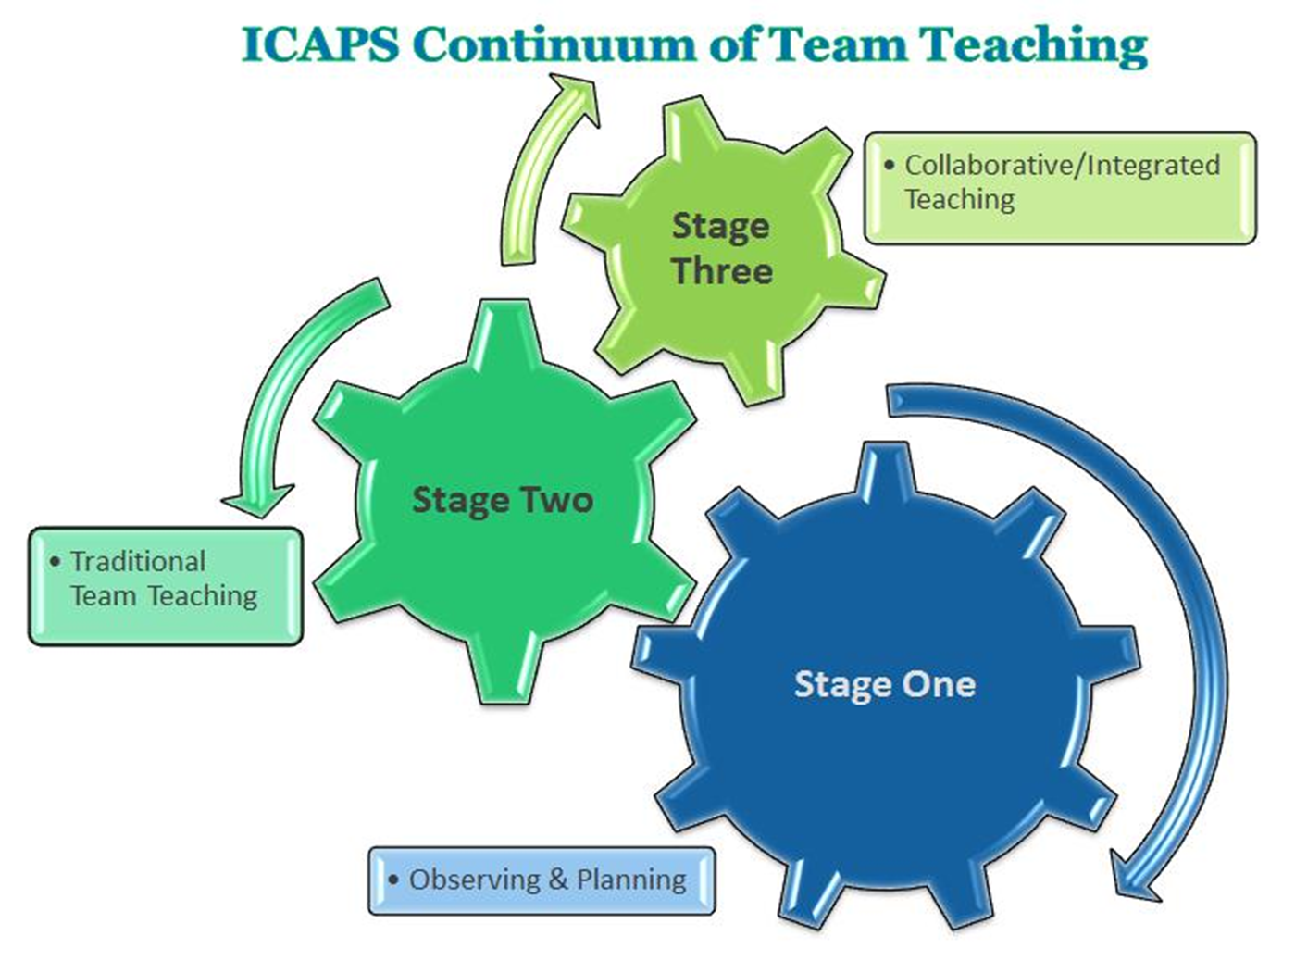
In addition to team teaching, a Support Course is required to provide students with additional support for the Career and Technical Course material. This Support Course is taught by the basic skills team teacher. It is strongly recommended that in preparation, the basic skills instructor audit the Career & Technical course during the term prior to beginning team teaching. This will allow the basic skills instructor to become familiar with the material. Another option is 100% overlap of instruction for the first term of team teaching, with the basic skills instructor auditing the Career & Technical course to be team taught and observing student reactions and understanding to learn where and when students are likely to have difficulties. These recommendations are to help ensure that both instructors are familiar with the material, allowing for thorough integration of technical training and basic skills education.

Stage One - Observing & Planning
- One teacher assumes the responsibility for instructing the entire class while the other teacher circulates the room and monitors student understanding. The monitoring teacher can then determine whether students understood the instruction and can provide immediate feedback.
- It can be helpful for the team to decide in advance what types of information are to be gathered during the monitoring so that it is a deliberate part of the lesson, not just teachers’ incidental checks of student activity.
Stage Two – Traditional Team Teaching
- In this stage, the two teachers share instruction. One teacher is responsible for teaching the content while the other teacher provides support, models learning strategies, and takes charge of providing follow-up activities on related topics or study skills.
- The support might include modeling an activity, providing examples, facilitating hands-on practice, or teaching strategies for remembering and organizing the information that is presented.
- This model is very effective for teaching academic skills and strategies such as note taking, listening for main ideas, and identifying new vocabulary.
Stage Three – Collaborative/Integrated Teaching
- The team teachers work together by exchanging and discussing ideas and theories allowing students to observe this process. This instructor interaction enhances the lesson by modeling how to compare diverse perspectives, learn from each other, and disagree respectfully. The lessons include student participation through small-group work, student-led discussion, and joint projects.
  - NOTE: This model/stage is the most difficult to incorporate, but most exciting for students. Because of the high level of integration required for such a format, this is seen as the deepest stage in the continuum of team teaching and is recommended only for those teams who have taught together for multiple terms and have a firmly established rapport.

WIOA Sec. 3(7) defines Career Pathways to mean a combination of rigorous and high-quality education, training, and other services that:

- aligns with skill needs of industries in the state or regional economy
- prepares an individual to succeed in secondary or postsecondary education options
- includes counseling to support the individual’s education and career goals
- includes education offered concurrently and contextually with workforce preparation
and training in specific occupation or occupational cluster
- organizes education, training and other services to support the particular needs of
an individual to accelerate their educational and career advancement
- enables an individual to attain a secondary school diploma or its recognized equivalent
- helps an individual enter or advance within a specific occupation or occupational cluster

Illinois Career Pathway Definition:

A career pathway means a combination of rigorous and high-quality education, training, and other services that aligns both vertically and horizontally across Secondary Education, Adult Education, Workforce Training and Development, Career and Technical Education, and Postsecondary Education systems, pathways, and programs. Collaborative partnerships with these entities and business and industry, along with human service agencies, corrections, and other community stakeholders, serve as the foundational structure for high-quality and sustainable career pathways.
A career pathway also includes multiple entry and exit points to facilitate individuals to build their skills as they progress along a continuum of education and training and advance in sector-specific employment. A successful pathway is often comprised of one or more career pathway programs.
A Career Pathways should:
- Align with the skill needs of industries in the economy of the State or regional economy
- Prepare an individual to be successful in any a full range of secondary or postsecondary education options, including registered apprenticeships
- Include counseling to support an individual in achieving their education and career goals
- Include, education offered concurrently with and in the same context as workforce preparation activities and training for a specific occupation or occupational cluster
- Organize education, training and other services to meet the particular needs of an individual in a manner that accelerates the educational and career advancement of the individual to the extent practicable
- Enable an individual to attain a secondary school diploma or its recognized equivalent and, at least, one recognized postsecondary credential
- Help an individual enter or advance within a specific occupation or occupational cluster

Partnership Team Instructions

Using the Tool Overview
The Illinois IET Self-Assessment Tool is designed to be an interactive instrument to help educational partners ensure they are meeting both the federal IET requirements AND the high standards set in Illinois. It is intended to guide a Partnership Team - or an internal self-review team - through the various expectations and quality indicators.

The intended audience for this tool is primarily those educational partners who are part of the development and implantation of an ICAPS/IET program and should be representative of the following:
- CTE Administrator or Dean
- Adult Education Director
- Faculty of course selected for ICAPS/IET Program
- Business and Industry Partners
- LWIA partners

The tool is organized around the required components of an ICAPS/IET program. These components are intended to assist stakeholders in the implementation and evaluation of their ICAPS program.

Each page of the tool highlights a different component. The user is asked to consider the specific component and associated elements, expectations, and evidence in order to make a determination of overall evaluation or assessment. To simplify and expedite this effort, the components/ elements have been grouped together based on similar characteristics.

Determining Status
Ultimately, the Partnership Team is asked to determine whether or not the ICAPS/IET program complies with the various compliance items and if the project has achieved any or all of the quality items. It requires significant knowledge of the program implementation. This is not a simple task, and it cannot be accomplished without a significant investment of time and resources to examine the entire scope of the program.

Component One: Establish a Partnership
Elements | Expectations | Evidence | Evaluation
Leadership supports:  - authentic collaborative partnerships  - shared decision making  - a collaborative culture  - aligned vision, mission and goals | - Partnership Leadership Committee is established and active  - Partnership Leadership Committee includes key stakeholders: CTE, adult education, business partners and LWIA  - Statement of partnership vision, mission and goals (short term and long term)  - Partnership operates under published rules that support collaboration | - Letters of commitment and support from key stakeholders (sample attached)  - Partners named (institutions and individuals)  - Partnership meeting schedule and minutes recorded  - Developed timeline for major decisions  - Does the IET align with Regional and/or Local Plan? Approval is the ICCB. | - Exceed Expectations  - Meets Expectations  - Working Towards Expectations
Reflection: | Notes:
What is missing?

How can we improve?

Where are gaps in our partnership?

Who else needs to be at the table?

Component Two: Integrated and Contextualized Adult Education Curricula
Elements | Expectations | Evidence | Evaluation
Determined primary focus of instruction – and outline sequence of courses  Team teaching with 25% overlap in content delivery  ICAPS Support Class – taught by an Adult Education Instructor  Transition and Support Services are provided | - Curriculum Alignment with AE CCRS  - Program is able to demonstrate contextualization/integration of instruction  - One of the three forms of team teaching is being implemented  - ICAPS support class meets once per week to provide follow-up and support for students  - Services offered to support underserved, underrepresented and special populations students  - Career Navigator is assigned  - Support services provided include the following services:  - Tutoring  - Child care  - Transportation  - Public benefits  - Subsidized jobs  High Expectations:  - Team teachers are at stage three on the team-teaching continuum  - Evidence of alignment efforts aimed at reducing remediation | - Shared curriculum that aligns with ICCB  - Program meets all ICCB ICAPS requirements  - Completed course approval form with ICCB  - Complete curriculum outline  - Complete syllabus for course  - Explain course delivery  - Does the IET align with Regional and/or Local Plan?  - Submit to ICCB for approval | - Exceed Expectations  - Meets Expectations  - Working Towards Expectations
Reflection: | Notes:
What is missing?

How can we improve?

Where are gaps in our curriculum?

Who else needs to be at the table?

Component Three: Integration of Workforce Preparation Activities
Elements | Expectations | Evidence | Evaluation
Integration of Illinois Essential Employability Skills (EES)  Integration of Digital literacy/technology skills | The ICAPS Program allows for  - multiple entry and exit points  - Stackable credentials.  - students to build and/or increase their “college knowledge” in order to make informed decisions  The ICAPS curriculum and pedagogy are designed to:  - reduce the need for remedial/developmental education  - develop, improve or expand the use of technology  Technology plan developed by relevant stakeholders | - Completers are prepared to attain a postsecondary credential, certificate or Associate degree  - Conducted the Essential Employability Skills Self-Assessment to identity areas where the framework can be integrated  - Sequences are coordinated and non-duplicative  - Sequences are aligned with industry standards  - Curriculum mapping notes/materials  - Technology Plan | - Exceed Expectations  - Meets Expectations  - Working Towards Expectations
Reflection: | Notes:
What is missing?

How can we improve?

Where are gaps in our workforce preparation activities?

Who else needs to be at the table?

Component Four: Integration of Workforce Training (depending on eligibility)
Elements | Expectations | Evidence | Evaluation
Occupational skill training  On-the-job training, i.e. internships, apprenticeships, pre-apprenticeships  Incumbent worker training with related instruction  Training programs operated by the private sector  Adult education and literacy activities, including English language acquisition and integrated education and training programs provided concurrently or in combination with services  Customized training conducted with a commitment by an employer or group of employers to employ an individual upon successful completion of the training | Skills upgrading and retraining  Entrepreneurial training  Transitional jobs  Job readiness training provided in combination with services | - Training agreements  - Registered Apprenticeships  - Business commitment in writing  - Evaluations of training | - Exceed Expectations  - Meets Expectations  - Working Towards Expectations
Reflection: | Notes:
What is missing?

How can we improve?

Where are gaps in our partnership?

Who else needs to be at the table?

