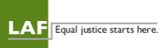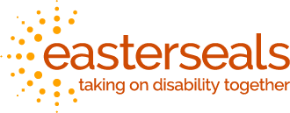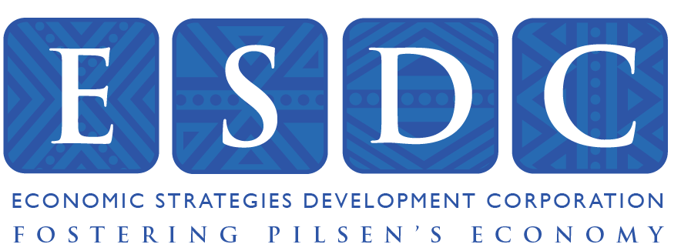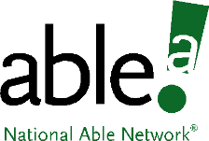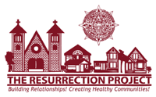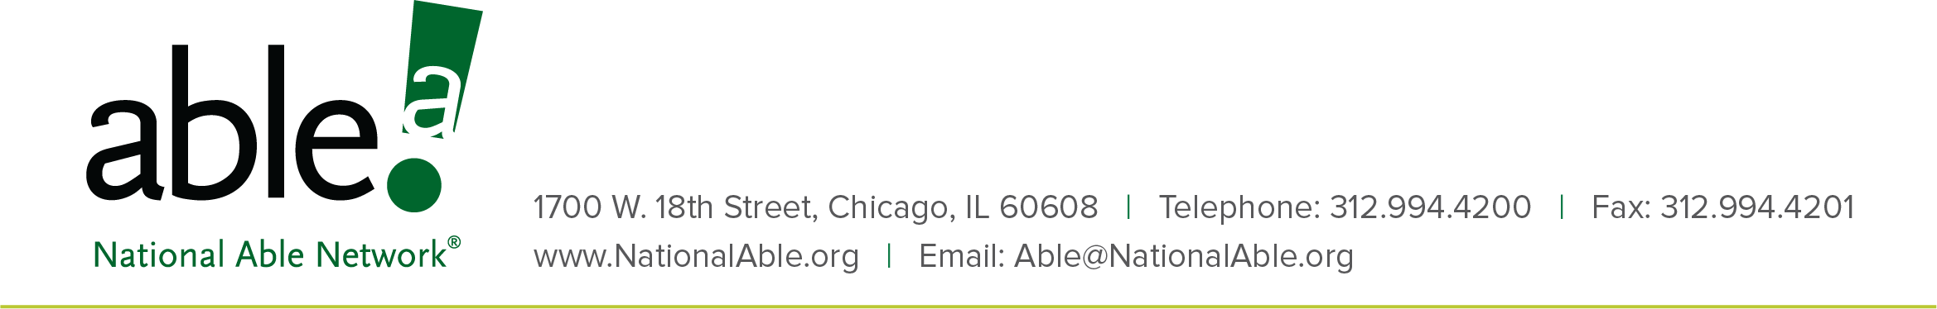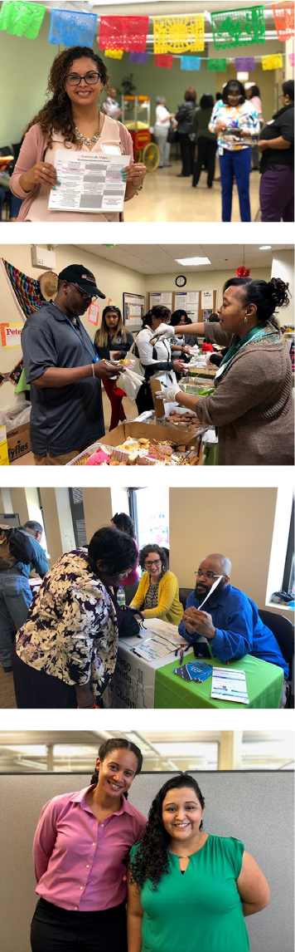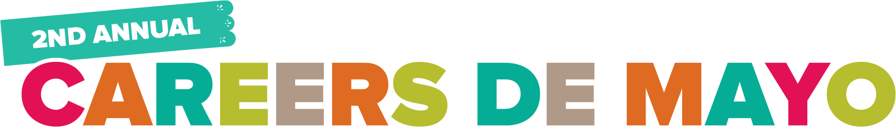

(DATE)

Dear (Contact),

On behalf of National Able Network and our partners, we are pleased to invite you to the Second Annual Careers de Mayo! This event will take place from 9:30AM to 2:00PM on Wednesday, May 15, 2019.

Careers de Mayo is an opportunity for community organizations and employers to connect with attendees and provide information on available resources and careers throughout the Chicagoland area.

We are proud to feature food from local Pilsen vendors, breakout sessions hosted by community organizations, activities, raffles, music, and more!

To reserve a table at no cost, [click here](http://events.r20.constantcontact.com/register/event?llr=shu4iomab&oeidk=a07eg3suapk36effaaa&condition=SO_OVERRIDE), or for more information, please contact Gabrielle Bell at [gbell@nationalable.org](mailto:gbell@nationalable.org) or Nora Arellano-Linard at [lalinard@nationalable.org](mailto:lalinard@nationalable.org) today!

Thank you for your continued support.

Sincerely,

Angela Lopez

Director

National Able Network