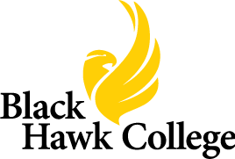
Please attend the
ACCELERATING OPPORTUNITY
Computer Numerical Control (CNC)
Manufacturing Certificate
STUDENT ORIENTATION
(Students should be prepared to register for classes
following the orientation session.)
Monday, August 4th
10:00AM – 11:00AM
Black Hawk College
6600 34th Avenue
Moline, Illinois
Building 2, First Floor Room 108
(CNC Lab)
(Please see map on back.)
For questions, please contact Kathy McCabe at:
309-796-8229 or mccabek@bhc.edu

